TC-DISP-017
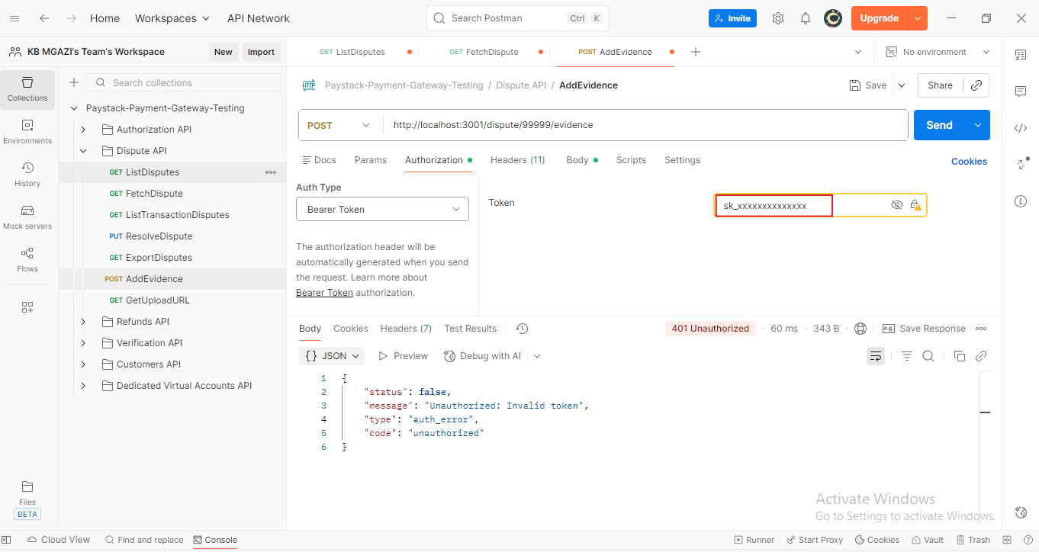
Response:
{
"status": false,
"message": "Unauthorized: Invalid token",
"type": "auth_error",
"code": "unauthorized"
}

